**Rare Media – Intentional Insights**

Christine Gardner

Colorado State University Global

Course Code: MIS 480

Jamia Mills

November 12, 2023

**Rare Media – Intentional Insights**

Marketing is a valuable service and provides businesses with the opportunity to help their customers extend their reach and grow their business. This valuable service can be enhanced if the provider understands how to optimize their business and resources to better provide for the customer. The Rare Media company is an example of a company that has lots of resources to provide their customers to help improve their customers’ improve their engagement. Rare Media provides lots of different services to their customers including local marketing, video marketing, citations building, link building, as well as website SEO (St. Louis, 2023). This company covers such a wide range of services that it would be beneficial to have a way to keep track of key metrics needed to provide the best service to its customers. As well as test theories that can help keep them ahead of competitors. The Rare Media company can use Business Intelligence to ensure that they are building strategic solutions that answer their customers’ needs in a efficient and effective manner.

**Organization Background**

Rare Media is a Marketing company that is located in Missouri. This company provides “quality local marketing services” (St. Louis, 2023). This company focuses on helping local companies increase there local marketing potentail. This is an interesting company because they provide value that bolsters the local economy, Rare Media helps people their customers stand out to the local public so that people don’t miss out on the companies that supply services or products in their immediate area. I chose Rare Media because as a marketing business they will understand the value of analytics as well as the value that comes with providing quality information to scale up a business. I also chose this company because they could benefit greatly from the insights that a business intelligence tool could bring to a local company. Rare Media provides initial services as well as ongoing support. To maintain on-going support the will need a way to manage all of their data and gain valuable insights that will ensure they maintain a reputation of providing exceptional service. put into place a business intelligence solution to help maintain exceptional service. Since Rare Media is a marketing company, they provide unique services that can really be enhanced by the insights that can be gained through analysis. A marketing company could benefit from a business intelligence solution in many ways some of which include tracking company metrics such as financial performance, marketing campagin success, and foundational research for new marketing strategies.

**Data Analytics Example**

There are many different uses that a marketing company could have for a business intelligence solution. Some of the uses include tracking revenue as well as customer conversion rates. Another use could be gaining insights and making predictions on the possible success of marketing techniques such as search engine optimization. Another major benefit of business intelligence tools is that it helps companies to test theories. In marketing it is crucial to a company’s success to have the ability to test theories in order to stay ahead of the competition with marketing tactics that are new and cutting edge while providing value to the customer. According to Hemann (2018), “an abundance of metrics are available to professionals, which makes landing on the ‘right’ metrics all the more challenging” so testing which metrics actually have an impact on the goals that a company wants to achieve is essential (pg. 20). Business intelligence tools can help companies to understand the metrics that have the biggest impact on their overall goals. One of the major services that Rare Media provides to its customers is video marketing. Video marketing is a way for Rare Media’s customers to appeal to their audience in an interactive way that appeals to multiple senses. According to West (2021) “if you’re looking to ramp up your video marketing strategy, it’s important to know how to measure its performance. And that all starts with knowing the right video metrics to track” (para. 1). To help increase the effective performance of the video marketing Rare Media could choose musical tracks that are more likely to draw an audience. This type of insight can be gained by using a business intelligence tool. According to Maaitah (2023) “business intelligence is a general category of applications and technologies used for collecting, accessing, and analyzing data to assist in decision-makers to make informed decisions” (pg. 43). Being able to make informed decisions with the massive amounts of data that is present is very important to achieve good analytics. There are multiple songs to choose from all throughout the world. Songs fall into various genres, are played in different keys, and have different beats per minute. A marketing company could take their best guess at trying to find songs to play for their video marketing or they could try and use song attributes to give them a better chance of using the audio element to help sway customers. The use of information / data helps to optimize Rare Media’s marketing process while allowing for a more standardized and less subjective process that can be repeated and refined to supply profitable results. Instead of the staff having to rely on intuition and their best guess they can use the results of their studies to predict which songs will engage the audience more. Business intelligence makes this possible “it is not exclusively equal too the information systems, since it also includes the conversion of necessary processes, technologies, and tools into infomration, the conversion of information into knowledge, and finally the conversion of knowledge into plans (Loshin, 2003). These Processes are the drivers of profitable nosiness activities” (Vilmos, 2020, pg. 305). Business intelligence provides such great value especially when it comes to testing new theories. An example of a theory that Rare Media can try and gain insight from is how the characteristics of chart-topping songs, and songs that are added to thousands of individual playlists affect the likes and views of a marketing video. This theory can also be expanded to see the effect of video views and likes on conversion rates, and revenue. Rare Media can test two song attributes from chart topping songs to see if those attributes have an effect on the videos appeal to customers The other theory that they can test is if songs that are less popular but have the similar attributes as chart topping songs increase the success of video marketing. With a business intelligence solution Rare Media would be able to gather and organize the data and then present in a way that answers these crucial questions. These theories are just a few examples of how Rare Media can use business intelligence to optimize the effectiveness of their marketing solutions. Tableau is a great tool that can help determine what music is the most effective in the video marketing portion of the company.

**Business Intelligence Tool**

Tableau is a straightforward business intelligence tool. This tool focuses on ease of use and insightful visualizations. These are important features for a local marketing company to have. The ease of use allows for the current staff to have the ability to learn how to use Tableau with ease while the company doesn’t have to pay for expensive staffing changes or build a department that is made to address only analytics with a platform that has a steep learning curve. Tableau gives users the ease of “parsing data, cleaning up data. So rather than having to go back to IT or to the actual data source, you can do it right there, in that last mile, just that last few feet, actually, right before you do the analysis” (Tableau, para. 55). Being able to make these last-minute changes makes it easy to build visualizations. Insightful visualizations are also extremely useful in marketing because they allow for interpretation of the information from various perspectives in easy-to-understand dashboards and reports. BI tools can “assists companies in gaining a competitive edge by helping them find new opportunities and build smarter strategies. With the help of all the data, you can identify market trends and help improve profit margins for the company” (Kalluri, 2023, para. 4). Tableau is a great resource for companies that want to build better strategies, while saving time, and using money in an effective way. Tableau is “visual data analysis and reporting tool that quickly and effectively reveals data relationships and anomalies that might take hours, or even days, for a traditional database tool such as Microsoft Excel Pivot Tables to identify” (Otey 2006 pg. 41). These are just a few reason reasons why Tableau is a great business intelligence tool.

**Outcomes**

The anticipated outcome of using this BI solution is a standardized basis for choosing the best songs for the video marketing service within the Rare Media company. The business intelligence solution is able to take data about chart topping songs and use it to gain insight on which songs are the most popular and what characteristics those chart-topping songs have. One report will show which attributes are repeated the most within the chart-topping tracks. This information can then be used to select songs that also have those characteristics. The reports will also show how the predicted song has impacted the views of the marketing video. Another report will display the effect of using the most streamed song and video marketing content. These types of insights will help Rare Media to ensure they are leveraging as much information as they can to get their customers the most results for their money. According to Maria (2023), “by studying how companies are using data to make strategic decisions, researchers can identify new approaches and techniques that can be used to improve business practices and drive growth” (pg. 3). This is something that Rare Media employees can do as well. Studying how decisions are made employees can work to make the proccess of choosing media content less subject to assumptions and based more on a resourceful insightful approach that can be repeated by various individuals with minimal basis. Once the insights are gathered Rare Media can use its staff and resources to focus on other pieces of marketing, freeing up their staff to provide value to the customer in other ways. The value of BI not only lies in the theories that a business can test, but also the ability to consider those theories in terms of their value and possibility for return on investment. If Rare Media observes an increase in viewing of their enhanced video marketing techniques, they can invest more resources in similar processes to optimize other parts of their marketing services.

**Data Sources**

Rare Media will be able to gather song data sets from Spotify to gain insights on which tracks are streamed the most and appear the most in playlist for a particular year. Rare Media will be able to export analytic reports directly to Tableau from You Tube to analyze the metrics that You Tube gathers on video content. The metrics that are prevalent to this theory are likes and views as well as Video Id. The last data set would ideally be available through Rare Media’s designated information system. This information system would contain customer data as well as current marketing campaign results, information about revenue, sales, conversions, and conversion rates, as well as profit and loss. This data set could be exported from the information system into an excel workbook like the data in that I have to simulate common marketing metrics. I have three data sets that I obtained from Kaggle to demonstrate how Rare Media can test theories. The data sets include a Spotify data set that I altered to include a primary key of Track Id, as well as You Tube metric data set that I included Track Ids in as well, and a common marketing data set that I added Video Ids to. Using three data sets will help to demonstrate the power of Tableau in gather insights across multiple data sources that can be used to test theories.

**Insights From Tableau**

These data sets flow from one set to the other as analysis progresses to research the theory. The first data set is used to gather information on what attributes the most streamed tracks, and the tracks that appear in the most playlist have. Figure 1 shows the tracks with the highest number of streams on Spotify as well as the tracks that appear the most in playlist. This information is compared with BPM and the track’s musical key. The most popular tracks on Spotify have BPM equal to 120, 110, 95, 124, or 92. The most popular tracks on Spotify in 2023 are played in the key C#. These insights can be used with the next set of data by ensuring the primary key Track Id is present in the You Tube metrics data set. In a less hypothetical study the track Id would be assigned by what song is actually played on the video present on You Tube, but in this case Track Ids were randomly assigned to each video. You Tube data set comes with it's on primary key of Video Id. This data set can be used to observe the engagement metrics that have been recorded for each video. Figure 2 shows the relationship between likes and views, and Video Ids of You Tube videos. These sheets can be used to compare which videos have the most amount of likes and views and what tracks were played on those videos. Since this is a hypothetical situation the data may not present what the results would be in the actual scenario, but the dashboard will give Rare Media an idea of the types of questions that they can answer. The next step is to see how the likes and views of the video impacts the marketing metrics found in the third data set. The third data set includes the Video Id as a primary key so that Rare Media can track a connection between Video Id and conversion rate, revenue, as well as profit and loss. Figure 3 depicts the dashboard that provides insight into which tracks and video has the highest revenue. The user can use this dashboard as a lead to figure out what the BPM minute of this track is and the key as well as the other highest-ranking videos in relation to revenue. Figure four depicts the relationship between revenue, conversions, and profit and loss. Even though the revenue is trending upward for certain videos in respect to the Video Id the profit and loss is negative for a massive amount of Video Ids. This can lead Rare Media to various insights. Such as the fact that the cost are too expensive to produce video content or the revenue gained from conversions is not enough to sustain effective profits. Rare Media can use these dashboards as a base for improving their video marketing by digging deeper into what could have a positive affect on revenue and video production cost.

**Figure 1**

*Spotify Tracks BPM and Key in Relation to Number of Streams and Number of Playlist Appearances*

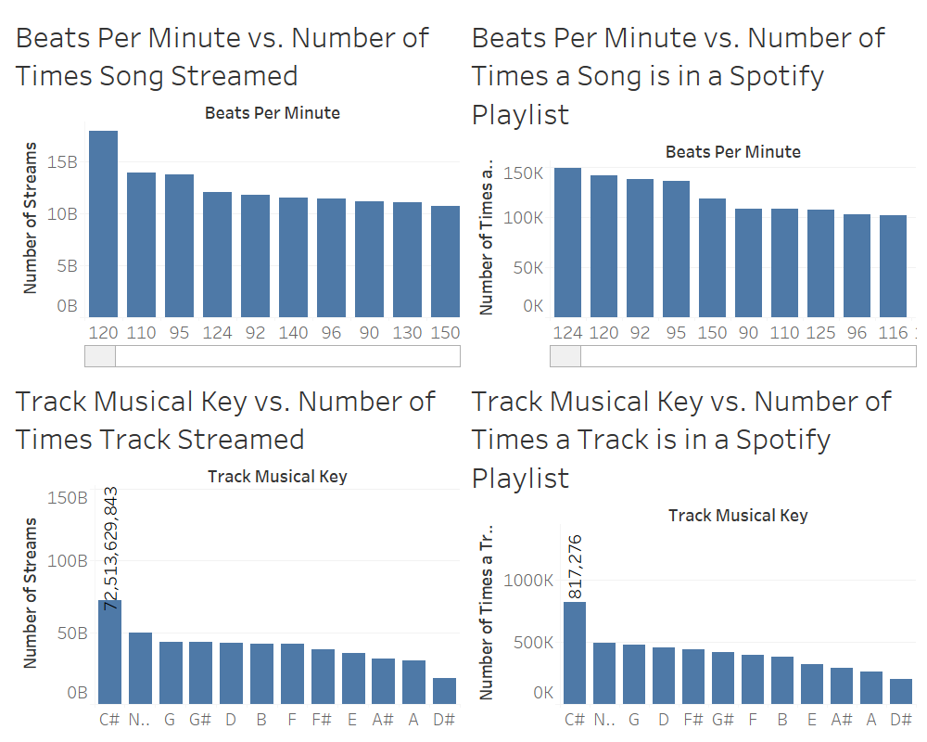

*Note*. This chart shows an example of what a dashboard looks like in Tableau. This dashboard combines analytics from 4 different worksheets. Each worksheet gives insight into comparing two variables in relation to each other, and the dashboard allows users to combine the worksheets easily to gain a bigger picture. This Dashboard presents a nice summary of data to answer the first part of the track theory. Rare Media can use these dashboards to spark the research of other theories such as if less popular songs with similar BPM or Keys to the top songs produce the same level of engagement as the popular songs with these attributes. This dashboard shows that songs that were made in the key of C# have been streamed the most totaling 72,513,629,843 streams. Rare Media can use this information to find songs that are played in C# for their video marketing to try in increase viewership. Over songs that are made in the key D# or A (N. E., 2023). Insights like these are what makes tools like Tableau valuable, because Rare Media can implement that strategy and measure its success using Tableau.

**Figure 2**

*Video Id in Relation to Video Count and Video Likes*

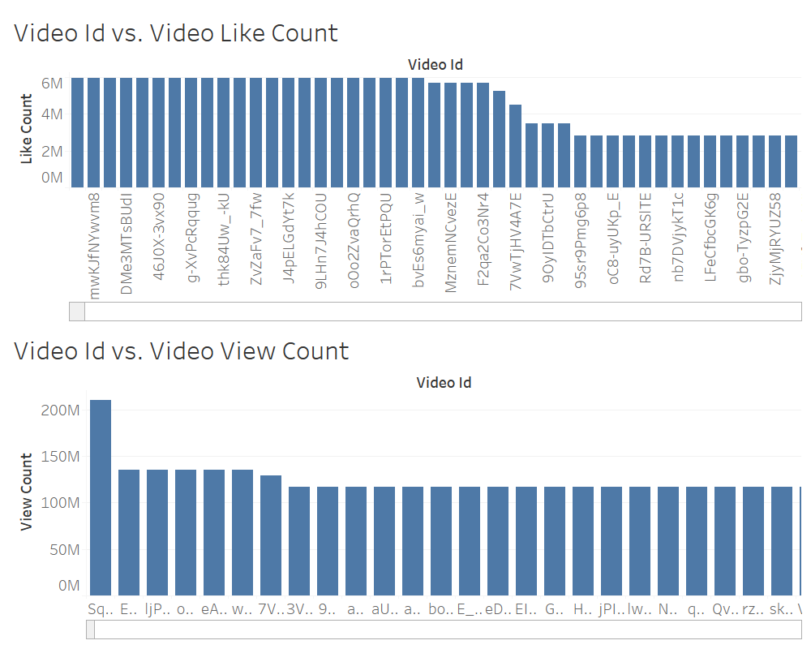

*Note*. This figure shows the relationship between the video views and the video likes. The likes and views are similar for videos that do contain a lot of likes so there maybe be a video attribute that contributes to this that was not analyzed in the initail research of this theory. The benefit of Tableau is that Rare Media can go back and drill down through the data and test other theories in cohesive dashboards with the click of a button. (Asaniczka, 2023).

**Figure 3**

*Marketing Metrics – Video Id vs Revenue with Track Id Data*

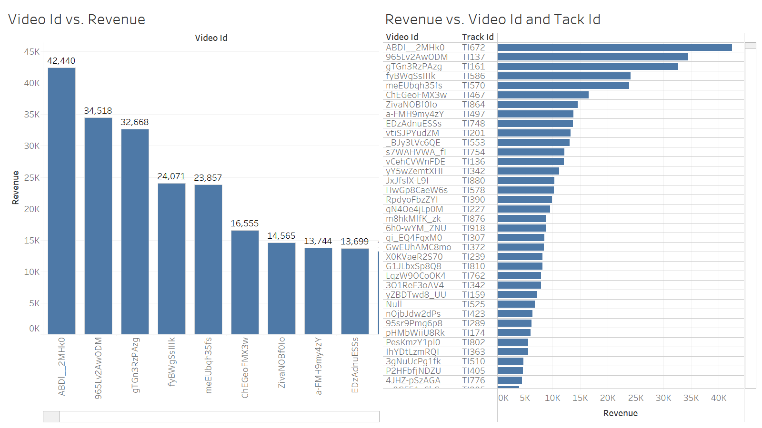

*Note*. This Dashboard shows the relationship between Video Ids and revenue while highlight which track was played in the video. This is an insightful visualization because Rare Media is able to expand on this data and see which tracks bring in the most revenue and whether or not those tracks were the ones with similar attributes to the most streamed Spotify tracks. For example Tack Id TI672 is played in key A and is 80 BPM. This is just one hypothetical data point but it gives the idea of the value that a tableau dashboard can bring to a company within minutes.

**Figure 4**

*Marketing Metrics – Video vs. Profit and Loss and Video Id vs. Conversion and Revenue*

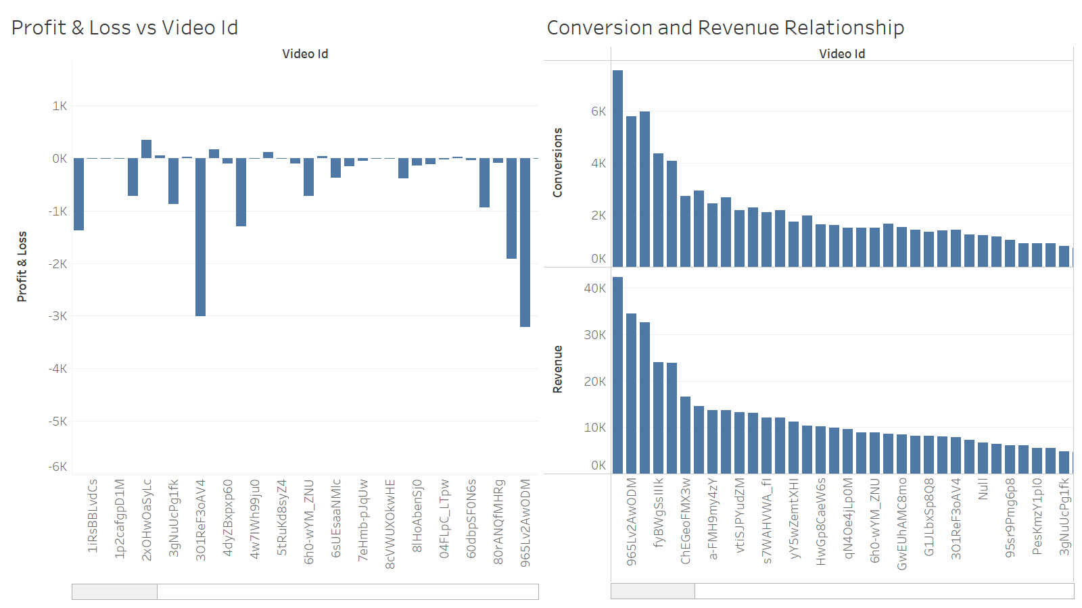

*Note*. This dashboard could be interpreted as one of the most important dashboards of all the ones presented in this analysis so far because it takes attributes like BPM and track key and ties it to important markers like revenue and conversions. This dashboard gives Rare Media insights on how well videos are doing as far as revenue and conversion. The videos with the highest conversion or revenue can be analyzed further to determine what track attributes they had, but this dashboard goes a step further and presents the profit and loss for the videos. Video Id 2xOHwOaSyLc (which is related to Track Id: TI222) has a higher profit than most other videos pictured in the dashboard, so it would be worth it to see what attributes this video had so that those pieces can be applied to other less profitable videos. The Track that was played in that video had 96 BPM and was played in key G#. This data doesn’t align with the most streamed songs, but since this is hypothetical data there might be a correlation that is not able to be seen. As far as this data set goes Rare Media would need to go back to the drawing board and analyze other avenues to understand how to increase profits through different attributes.

**Conclusion**

Overall Tableau was able to provide straight forward interactive dashboards that help to spark answers to the questions on how to make video marketing more profitable. This no code solution allows users to analyze data with ease. The outcome of this data shows that there needs to be more research conducted in order to find an effective way to increase profits, which is a valuable insight. The insight would allow a company to address areas that they need to improve in and add those metrics to their plan for strategic growth opportunities. This leads the company to try and find effective answers. There are trends that the company can test and apply to their video creation strategy to in order to help reduce the cost of video production or increase the efficiency in the time it takes to create videos that increase customer engagement. Tableau is a business intelligence solution that can help the Rare Media company explore those theories and apply the insights that they gather in a way that increases revenue and positively impacts profits.

**References**

Asaniczka. (2023, November 12). *Daily trending YouTube videos (113 countries)*. Kaggle. <https://www.kaggle.com/datasets/asaniczka/trending-youtube-videos-113-countries>

D, M. (2022, September 29). Shopping mall paid search campaign dataset. Kaggle. https://www.kaggle.com/datasets/marceaxl82/shopping-mall-paid-search-campaign-dataset

Hemann, C., &amp; Burbary, K. (2018). Digital Marketing Analytics: Making sense of consumer data in a Digital World. Pearson Education, Inc.

Kalluri, K. (2023, June 7). Advantages of business intelligence tools [10 insightful points]. SplashBI. <https://splashbi.com/advantages-of-business-intelligence-tools/>

Maria Popescu, M. A. (2023). The Era of Business Intelligence Tools. FAIMA Business & Management Journal, 11(2), 3–4.

Maaitah, T. (2023). The Role of Business Intelligence Tools in the Decision Making Process and Performance. Journal of Intelligence Studies in Business, 13(1), 43–52. https://doi.org/10.37380/jisib.v13i1.990

N. E. (2023, August 26). Most streamed Spotify Songs 2023. Kaggle. <https://www.kaggle.com/datasets/nelgiriyewithana/top-spotify-songs-2023/>

Otey, M. (2006, March). Tableau Software 1.5. SQL Server Magazine, 8(3), 41. <https://link-gale-com.csuglobal.idm.oclc.org/apps/doc/A143921388/AONE?u=colstglobal&sid=ebsco&xid=9a6b5703>

St. Louis Seo and digital marketing agency - rare-media - rare-Media Digital Marketing

Agency. Rare. (2023a, April 10). <https://rare-media.com/>

Tableau Software Inc at Goldman Sachs Technology & Internet ConferenceÂ - Final. (n.d.). Fair Disclosure Wire (Quarterly Earnings Reports).

Vilmos, L., László, T. V., & Bernadett, B. M. (2020). Supporting Corporate Decision-Making with the Tableau Program. Annals of the University of Oradea, Economic Science Series, 29(2), 304–314.

West, C. (2021, October 18). 7 video metrics you need to know to measure success. Sprout Social. <https://sproutsocial.com/insights/video-metrics/>